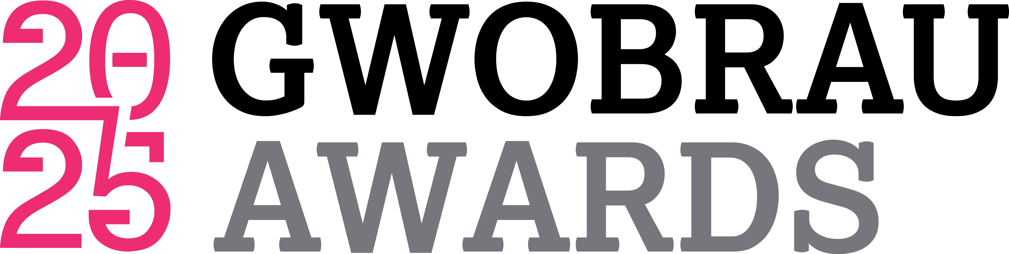

CALL FOR PROPOSALS
The A&B Cymru Awards exist to encourage, acknowledge and celebrate exemplary partnerships between the private sector and the arts across Wales. In 2025, the flagship event will take place at ICC Wales, Newport on Thursday 19 June 2025. Guests will include senior representatives of business, the arts and public life.
The Awards entertainment has a long-established reputation of being spectacular, unexpected and of the highest quality. As 2025 marks the ceremony’s 30th Anniversary, A&B Cymru is particularly keen to ensure that the performances are both memorable and celebratory. All acts are kept confidential until the evening of the Awards.
A&B Cymru is inviting its arts members to submit ideas to perform. Two opportunities are available – a 5-10 minute performance at the beginning of the formalities (approximately 7.45pm) and a 20-minute performance at the end of the ceremony (approximately 10.30pm).
Should you wish to apply for one or both of these unique showcasing opportunities, please complete this form and return it to A&B Cymru no later than Friday 14 March.
Contact Details
- Contact Name & Position
- Arts Organisation
- Telephone
- E-mail

5-10 minute Performance
As this performance begins the event, we are looking a visually spectacular act lasting no more than 10 minutes. Please describe your proposed performance.
If possible, please include a link to past performances.
Please use no more than 200 words
- Number of Performers & Technical Requirements
- Approximate cost / expenses

20-minute Performance
As this performance ends the 30th ceremony, we are looking for a highly entertaining act with a celebratory feel which lasts no more than 20 minutes. Please describe your proposed performance.
If possible, please include a link to past performances.
Please use no more than 200 words
- Number of Performers & Technical Requirements
- Approximate costs / expenses

Please return to contactus@aandbcymru.org.uk no later than 14 March

